|  |  |  |
| --- | --- | --- |
|  | Phone App User Manual | |
| 8/23/2013 | Graduate Capstone |  |

# Table of Contents

Table of Contents 2

1 Introduction 3

1.1 Intended Audience 3

1.2 References 3

1.3 Revision History 3

2 Set Up 4

3 Navigation Actions 4

4 Booting the App 4

5 Splash Screen 5

6 Main Panorama 5

6.1 Quick Start 6

6.2 Navigation 6

7 Browsing Companies 7

8 Company Panorama 8

8.1 Company Information 8

8.2 Survey Information 8

9 Survey 9

9.1 Structure 9

9.2 Form Elements 9

9.2.1 Labels 9

9.2.2 Textbox and Textareas 10

9.2.3 Radio Button Group 11

9.2.4 Slider Bar 11

9.2.5 Dropdown Box 12

9.3 Submit Survey 13

10 Frequently Asked Questions 14

10.1 How to Find a Company 14

# 1 Introduction

The purpose of this document is to give a tutorial and walkthrough on how to navigate and use the Receipt Reward Application.

## 1.1 Intended Audience

This document is intended for any persons who wish to utilize the Phone Application and gain a better understanding of how the screens work. This document is written for people with any degree of familiarity with the application.

## 1.2 References

No references were used.

## 1.3 Revision History

Managing the change history of this document will occur in this table.

|  |  |  |  |
| --- | --- | --- | --- |
| Name | Date | Reason For Change | Version |
| Andy Bottom | 08/13/2013 | Created the introduction and parts of the document. | 0.1 |
| Andy Bottom | 08/20/2013 | Finished complete manual | 1.0 |

# 2 Set Up

The following assumption is made that the application is already installed on the desired device. If this is not the case, please contact Administrators of Receipt Rewards and they can direct you on where to find and install the application on your device.

# 3 Navigation Actions

Prior to navigating the application, there are several controls and actions that are important to go over.

* Click: This action of clicking on a link is used to navigate from one page to another.
* 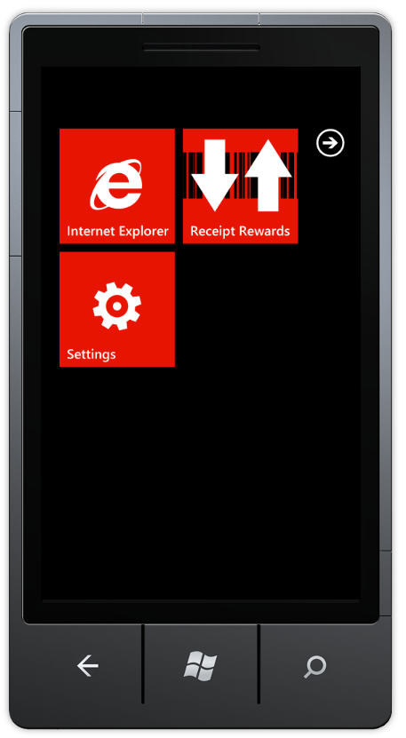Swipe: On panorama view, pages are located next to one another. To navigate to a new page in this type of view, simply swipe your finger and drag in the direction you want. This will slide the panorama over and display the page.
* Back Button: The physical back button on the phone is used to navigate backwards to previous pages.

# 4 Booting the App

The app will be found on the under the list of apps. If the app is pinned to your start menu, you may find it there as well. To start the app, simply click on the Receipt Reward Application. This starts the boot process and the loading screen should follow immediately after clicking the application.

# 5 Splash Screen

As mentioned in the previous section, after selecting the Receipt Reward application, the application will start up. During the booting process, the splash screen should become visible. This screen has no functionality or interactive aspects to it. It’s only function is to provide the logo of the application. This screen allows for the use to see that the process of the app opening is currently active and that the application will be loaded and ready for use momentarily.

This screen loads very fast and the application should be ready within 1 to 5 seconds. If the splash screen is still being shown and the time elapse exceeds 15 seconds, this may indicate another problem. The best solution for this occurrence is to restart the phone.

# 6 Main Panorama

The first view that will be displayed to the user is the main panorama view. Since this is a panorama view, it contains multiple pages next to each other. By doing this, the most important functionality can be easily accessible and used.

## 6.1 Quick Start

The quick start menu brings the functionality that you want directly to you in the fastest way possible.

To start a survey, simply type in the company name you would like to fill out a survey for. The results will then display. Next, simply click the company link and you will be sent to the survey page.

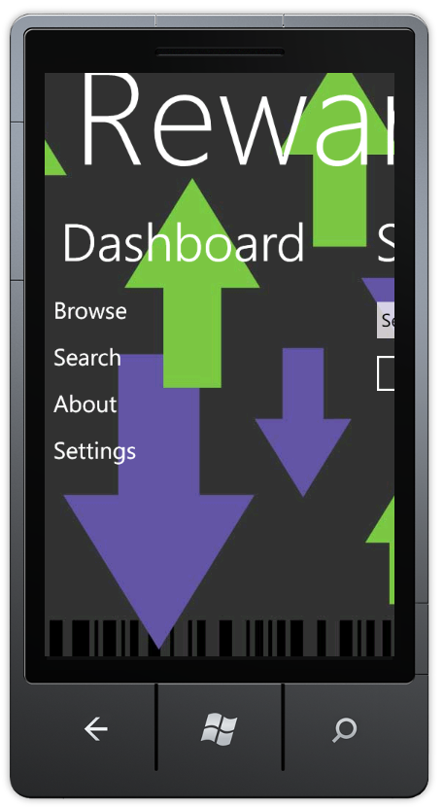

## 6.2 Navigation

The navigation menu has a list of links to the main functionality of the application.

# 7 Browsing Companies

The ability to find and learn about new companies is very important aspect to the user. To achieve this, use the Brose Company function. This page is simple a complete list of all the companies that are in the system.

Each company in the list has been verified to offer the satisfaction surveys and rewards. To learn more about the company, simple click on the company name, and that will bring you to the Company Information View.

# 8 Company Panorama

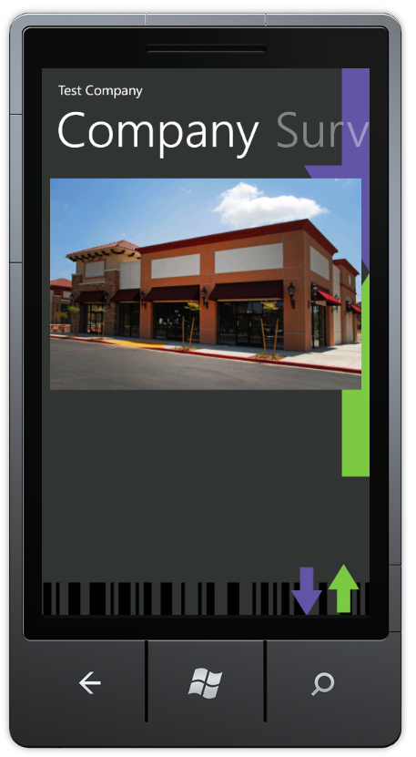The Company Panorama view contains the information about a company and its corresponding survey.

## 8.1 Company Information

The company information page contains details about company. The page contains an elegant picture of the company as well as helpful fact about the company for those who may not be familiar.

Some of the categories and facts that you will learn include:

* Business Type
* Locations
* Website
* Founding Year

## 8.2 Survey Information

The survey information page contains details about the survey. Such information includes: Redeemable Code or Coupon, the estimated time the survey will take, etc… If you want to take the survey, then all you have to do is click the “Start Survey” button, and you will be directed to the actual survey.

# 9 Survey

## 9.1 Structure

The survey structure is very self-intuitive. When you start the survey, you will be immediately given the first question. None of the, are you ready to take the survey nonsense. We get straight to the point to get you done faster and get the reward in your hand sooner

In addition, we don’t use any backwards navigation through the survey. The back button on the phone will take you back to the company page. But be careful, as we currently do not save your answers for you. So, please use with caution.

## 9.2 Form Elements

In order to make the process of filling out the application, we’ve focused on using the most intuitive form elements. By doing this, we make it as easy as possible for input.

### 9.2.1 Labels

Labels are a useful element that is used to display the question to you.

### 9.2.2 Textbox and Textareas

The Textbox and Textarea controls are a great way to get input from you. Typically, these controls are used on questions that are intended to be open ended or fact of some kind. You can see below examples of both input elements and how they display on the field.

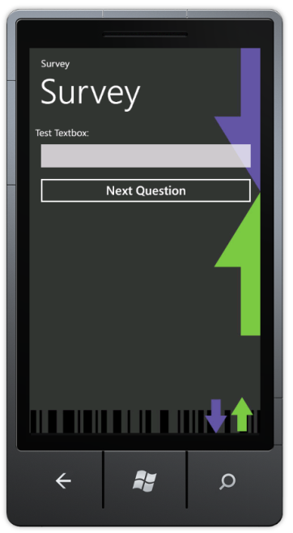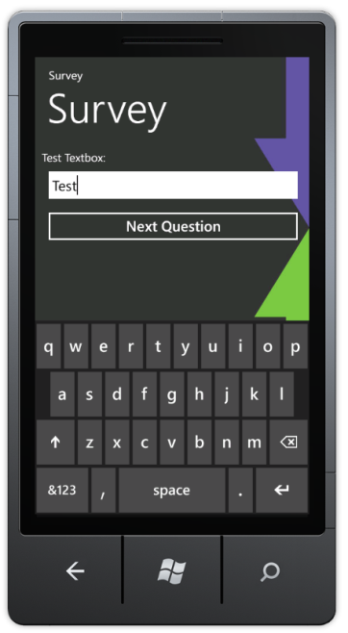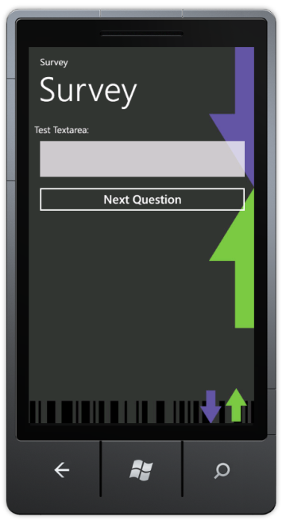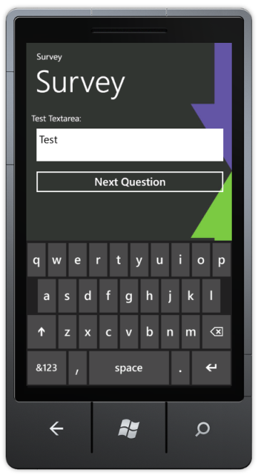

### 9.2.3 Radio Button Group

Radio Button Groups are the rounded buttons that indicate that only one value of the following can be chosen. Radio buttons are often used with questions which have predefined answers that are acceptable.

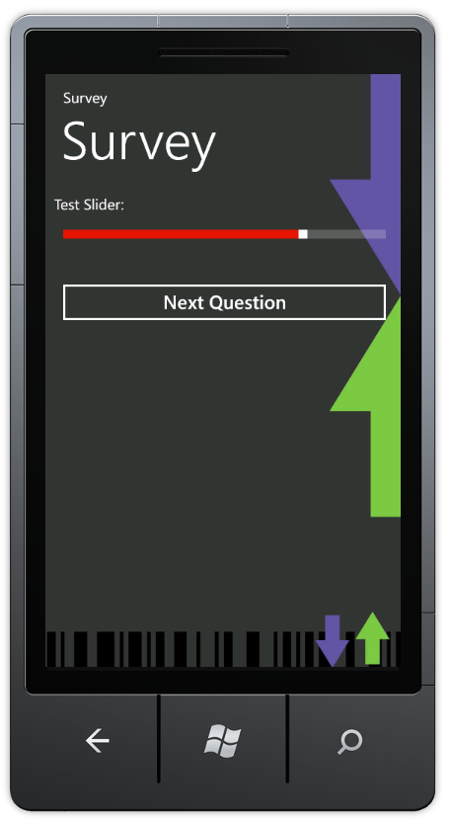

### 9.2.4 Slider Bar

The sliding bar is a horizontal bar which users can click and slide to change the value. Typically, sliding bars will be used on questions involving a rating scale. In direction, the left side of the bar is negative and the right side of the bar is positive. Neutral is in the middle.

### 9.2.5 Dropdown Box

The dropdown list is an alternative way to answer from a list of options. To choose an option, simply click the drop down box. The dropdown will expand to a full screen list of all the options. To selection an option, simply click the desired option and that value will be displayed in the dropdown box.

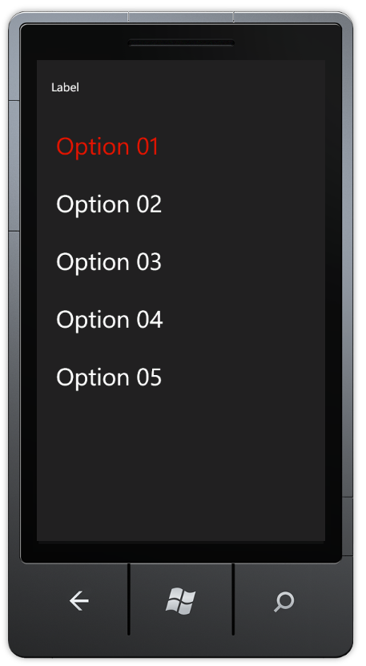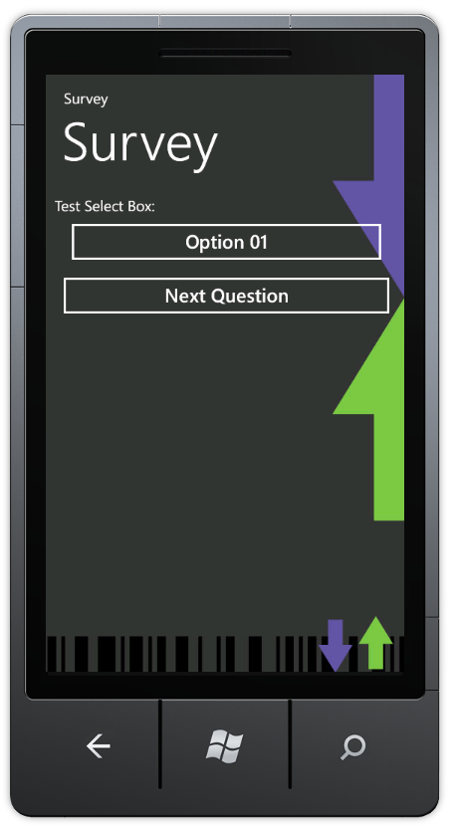

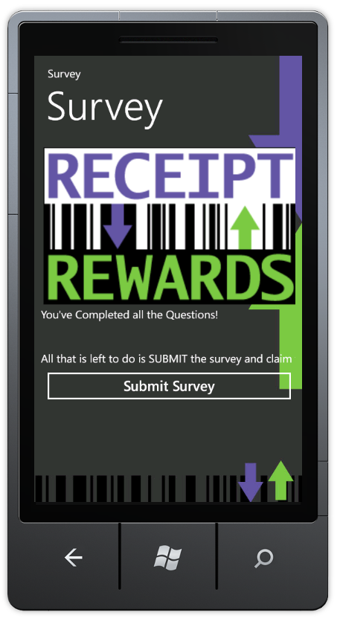

## 9.3 Submit Survey

When you have reached the end of the survey, you will reach the “Submit Survey” page. This page informs you that you have successfully finished the survey and are ready to submit your answers. To submit, click the “Submit Survey” button.

Upon submitting that application will run the results and return back your reward information. It may take a few moments to retrieve your reward.

# 10 Frequently Asked Questions

## 10.1 How to Find a Company

You can discover companies in a variety of ways. If you want to find a specific company, use the search and search by the company name. If you want to discover other companies, use the browse feature. If the company that you are looking for has a survey, but is not in the system, the contact Receipt Rewards, and we will do our best to add that company to our system.